MINI-PROJECT REPORT

WIPER CONTROL SYSTEM

NAME: N.Praneetha.

TABLE OF CONTENTS

|  |  |  |
| --- | --- | --- |
| SERIAL NO | CONTENT | PAGE NO |
| 1 | Abstract | 3 |
| 2 | Introduction | 3 |
| 3 | Features | 4 |
| 4 | 4W’S 1H | 4 |
| 5 | SWOT Analysis | 5 |
| 6 | Requirements | 5,6 |
| 7 | Architecture | 7,8 |

* ABSTRACT:-

Wiper is an essential component that used to wipe the raindrops or any water from the windscreen. Wipers are designed and made to clear the water from a windscreen. Most of cars have two wipers on the windscreen, one on the rear window and the other on each headlight. The wiper parts visible from outside the car are the rubber blade, the wiper arm holding the blade, a spring linkage, and parts of the wiper pivots. The wiper itself has about six parts called pressure points or claws that are small arms under the wiper.As a result, this method is proposed to address this issue. The project's goals are to improve ageing the automobile systems by giving automated transmission. Most of the cars have two wipers, one on the rear window and other on the front glass.wipers as fast as they need to move. Now a days we have the automated control wiper system whenever we stop wiping in between the process it will automatically come to initial position this is the new wiper system behind the wiper arm. This proposed wiper system's principle is comparable to those of other existing conventional wipers.

* INTRODUCTION:-

Car glass that is exposed to dirt or rainwater will usually be cleaned using a wiper. usually, the wiper is attached to the front and rear sides with the wiper, the driver's view will not be hindered and so they can see clearly towards the front or rear.Existing system manually used control stalk to activate wiper and the process of pulling up wiper is difficult to be handled.Whenever the water hit a dedicated sensor that located on windscreen, it will send a signal to move on the wiper motor.Once water is not detected by sensor, the wiper will automatically stop. This will help the driver to give more concentration and reduce the car accident probability.

* FEATURES: -

1.It shall lock the car when the button is pressed once.

2.It shall open the car when the button is pressed twice.

3.It shall wiper on and it moves clock wise direction and when the button is pressed thrice.

4.It shall wiper off and it moves anti clock wise direction and when the button is pressed four times.

5.It shall wiper complete one cycle when the button is pressed five times.

* 4W’S 1H:-
  + **WHERE:**

Most of the vehicles have two wipers on the wind shield one on the rear windshield and the other on the front wind shield.

* + **WHY:**

Main purpose of to use wiper control system to clean the wind screen easily and to visible the wind screen perfectly.

* + **WHEN:**

The maily used to raining time and to clean the oil and dust particales ext.

* + **How:**

To use the wiper system tecnnique and to attach the motor and wiper sensor is used to clean the wind screen easily.

* SWOT Analysis:-
  + STRENGTH:

Decrease the accident situation. Decrease the fuel consumption. Increase the safety.

## WEEKNESS:

Speed control is limited. Maintainance cost is high. Does'nt maintain the every people.

## OPPORTUNITIES:

This type of technology is very useful for every people. It is enable for MTM applications.

## THREATS:

User acceptance. Cost. MTM delayed adapation.

* Requirements:-

**High Level Requirements:**

| **ID** | **DESCRIPTION** | **STATUS** |
| --- | --- | --- |
| HR01 | It shall lock the car | Implemented |
| HR02 | It shall unlock the car | Implemented |
| HR03 | It is Activate the wiper control system | Implemented |
| HR04 | It is deactivate the wiper system | Implemented |

**Low Level Requirements:**

| **ID** | **DESCRIPTION** | **STATUS** |
| --- | --- | --- |
| LR01 | If the user pressed the button once to on RED LED. | Implemented |
| LR02 | If the user pressed the button twice off to the RED LED. | Implemented |
| LR03 | If the user pressed the button three times the LED ON FOR BLUE,GREEN,ORANGE LIGHTS. | Implemented |
| LR04 | If the user pressed button four times the LED ON FOR ORANGE,GREEN,BLUE LIGHTES. | Implemented |

* **Architecture**:-

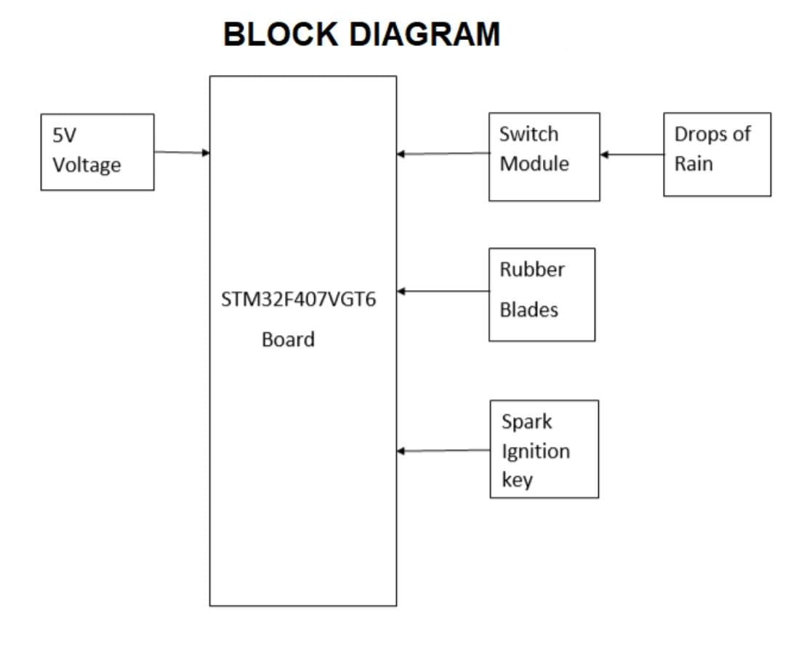

FLOW CHART:-

